Second May Bank Holiday Weekend 2020
Communications toolkit

1) Website copy for partners

Healthcare information and advice for the second May bank holiday weekend 2020
This weekend (23, 24 and 25 May) people living in Birmingham and Solihull are being reminded of their healthcare options should they or their families feel unwell over the long weekend, as some services may not be open as normal.
A range of information and options can be found below, and via the links.
COVID-19 Care Assistant: This free 24/7 online service, accessed through Ask A&E and powered by Babylon, offers information on COVID-19 and self-isolating, with a free online symptom checker and access to live chat (8am-8pm) with University Hospital of Birmingham NHS Foundation Trust clinicians.
Pharmacy: Pharmacies will be treating Monday 25 May 2020 as a normal bank holiday. You can find out which Birmingham and Solihull pharmacies are open on bank holiday Monday here. Please do not attend if you have COVID-19 symptoms.
GP practice: GP practices will be closed over the Bank Holiday weekend (Saturday 23rd May to Monday 25th May 2020). Patients will be able to access GP services if required by calling their practice as normal. They will then be transferred to GP services providing cover for their practice.
NHS 111: This is available 24/7 by calling 111 or visiting https://111.nhs.uk/
Walk-in, urgent care or urgent treatment centres: Locally, some of these options are still available – please check on the NHS website to ensure that your local site is open. Please do not attend if you have COVID-19 symptoms.

2) Social Media
a) Resources
Twitter
Thursday  It looks like we’re going to have some sunny weather this #bankholiday weekend in #Birmingham and #Solihull – we hope you have a lovely time!  However, if you’re unwell, there are a range of options available to you. To find out more visit: https://bit.ly/2LJNz9Z | 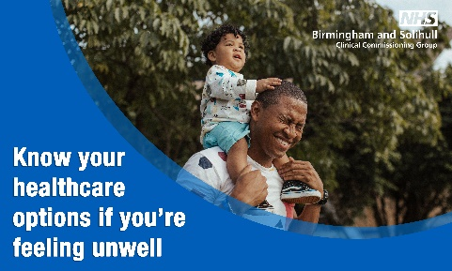  * May Bank Holiday Image 1
Friday  Are you looking forward to the long weekend?!  While we hope everyone in #Birmingham & #Solihull is able to relax & enjoy some time in the sun, in the event that you or someone you care about is poorly, be sure to get the help you need.  For help, visit: https://111.nhs.uk/ | 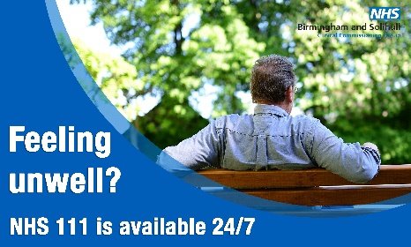  * May Bank Holiday Image 2
Saturday  Monday is a bank holiday and many pharmacies will not be open or will operating on reduced hours.  For more information on your local pharmacy in #Birmingham and #Solihull visit: https://bit.ly/2WOlBzY | 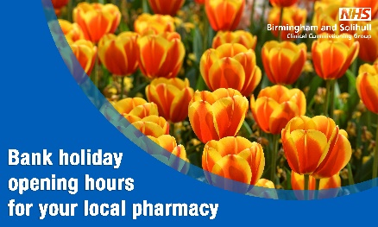  * May Bank Holiday Image 5
Saturday AM  This bank holiday weekend in #Birmingham and #Solihull, make sure you know where to go if you or someone you care about is feeling unwell.  For advice on what to do or where to go, visit: https://bit.ly/2LJNz9Z | * May Bank Holiday Image 4
Saturday PM  While many people across #Birmingham and #Solihull are enjoying the sun and the long weekend, tonight marks the end of Ramadan for Muslims.  Eid-ul-Fitr Mubarak to all those celebrating! Please remember to practice social distancing and stay safe. | 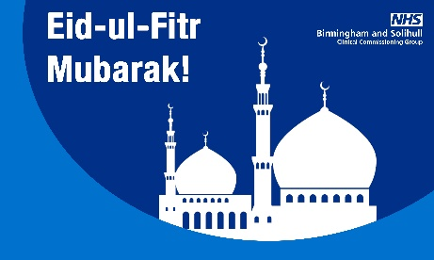  * Eid Image
Sunday AM  Tomorrow is a bank holiday and like most local people in #Birmingham and #Solihull, we’re hoping to enjoy the warm, sunny weather!  But do you know what to do if you’re feeling under the weather? To learn more about the options available to you, visit: https://bit.ly/2WOlBzY | 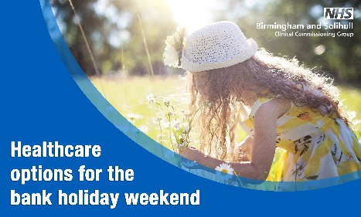  * May Bank Holiday Image 3
Sunday PM  This bank holiday weekend in #Birmingham and #Solihull, if you need support with your #MentalHealth and #wellbeing; it’s available 24 hours a day, 7 days a week. Please call: 📞0121 262 3555  Learn more at: https://bit.ly/2WPIB1G #mentalhealthawarenessweek | * May Bank Holiday Image 1
Monday AM  Today is a bank holiday and many pharmacies will be open for a minimum of 3 hours. To find out the opening times for your local pharmacy in #Birmingham and #Solihull visit: https://bit.ly/2WOlBzY | 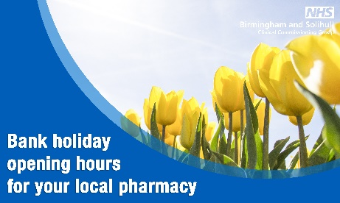  * May Bank Holiday Image 6
Facebook
Thursday  It looks like we’re going to have some sunny weather this #bankholiday weekend in #Birmingham and #Solihull! Remember if you are out in the garden, or visit a park to stay hydrated and apply sun protection.  If you find yourself feeling unwell, there are a range of options available to you. To find out more visit: https://bit.ly/2LJNz9Z | * May Bank Holiday Image 1
Friday  Are you looking forward to the long weekend?!  Whilst we hope everyone in #Birmingham & #Solihull is able to relax & enjoy some time in the sun, in the event that you or someone you care about is poorly, be sure to get the help you need.  NHS111 is available 24/7 online https://111.nhs.uk/ or by calling 111. | * May Bank Holiday Image 2
Saturday AM  Remember, Monday is a #bankholiday and many pharmacies will not be open or will operating on reduced hours.  For more information on your local pharmacy in #Birmingham and #Solihull visit: https://bit.ly/2WOlBzY | * May Bank Holiday Image 5
Saturday PM  Tonight marks the end of #Ramadan for Muslims.  Please remember to practice social distancing and stay safe.  Eid-ul-Fitr Mubarak to all those celebrating! | * Eid Image
Sunday PM  This #bankholiday weekend in #Birmingham and #Solihull, if you need support with your #MentalHealth and #wellbeing; it’s just a phonecall away.  If you’re feeling worried, stressed, anxious or having trouble sleeping, help is available, 24 hours a day, 7 days a week.  Please call: 📞0121 262 3555  Learn more at: https://bit.ly/2WPIB1G #mentalhealthawarenessweek | * May Bank Holiday Image 4
Monday AM  Today is a bank holiday and many pharmacies will be open for a minimum of 3 hours.  You can find out the opening times for your local pharmacy in #Birmingham and #Solihull visit: https://bit.ly/2WOlBzY  If you need urgent health advice remember you can call NHS111, 24/7. | * May Bank Holiday Image 6
Instagram
Friday  It looks like we’re going to have some sunny weather this #bankholiday weekend in #Birmingham and #Solihull – we hope you have a lovely time!  However, if you’re unwell, there are a range of options available to you. To find out more visit: https://bit.ly/2LJNz9Z | 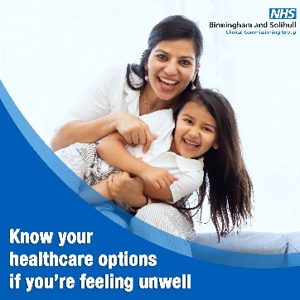  * May Bank Holiday Image 4 - Instagram
Saturday PM  Tonight marks the end of #Ramadan for Muslims.  Please remember to practice social distancing and stay safe.  Eid-ul-Fitr Mubarak to all those celebrating! | * Eid Image
Sunday AM  It looks like we’re going to have some sunny weather today in #Birmingham and #Solihull! Remember if you are out in the garden, or visit a park to stay hydrated and apply sun protection.  If you find yourself feeling unwell, there are a range of options available to you. To find out more visit: https://bit.ly/2WOlBzY | 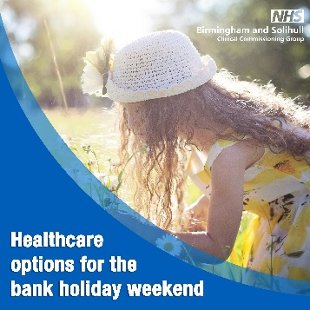  *May Bank Holiday Image 3 – Instagram
Monday AM  Today is a bank holiday and many pharmacies will be open for a minimum of 3 hours.  You can find out the opening times for your local pharmacy in #Birmingham and #Solihull visit: https://bit.ly/2WOlBzY  If you need urgent health advice remember you can call NHS111, 24/7. | 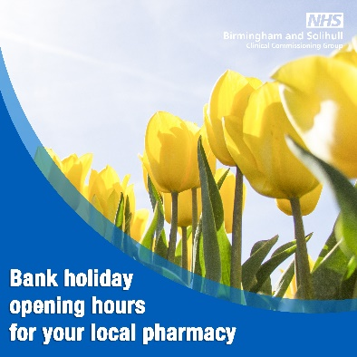  * May Bank Holiday Image 6 - instagram

